
DK-AHD7066-5M
5mp Waterproof dome Camera
4 in 1 TVI/CVI/AHD/CVBS
Key Feature：

1. High preformance HD 5mp cmos Sensor
2. Day/Night(ICR), AWB, AGC, BLC,2D,3DDNR,
3. 24pcs infrared leds
4.Lens: 3.6mm/6mm/8mm/12mm optional
5.OSD function
6.Waterproof IP66

Picture:
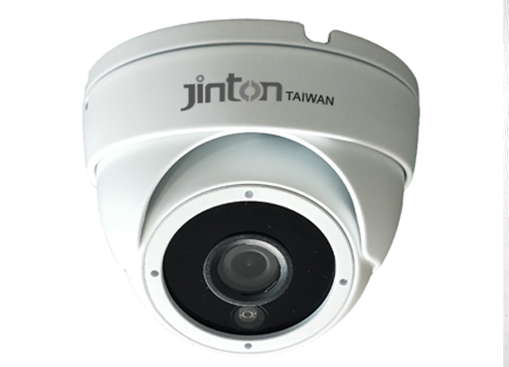
Spec:

Model | DK-AHD7066-5M
Image Sensor | 1/3" 5MP GC4653 cmos Sensor
Resolution | 5MP
Signal System | PAL/NTSC
Lens | 3.6/6/8mm/12mm fixed megapixel lens
Video Output | 5MP TVI/CVI/AHD/CVBS 4 in 1
Led | 24pcs infrared，20m night vision
Function Control | OSD
Electronic Shutter | Auto/Manual
Minimum illumination | Color:0. 1Lux@(F1.2,AGC ON),0Lux with IR ON
Minimum illumination | Black and white: 0.01Lux@(F1.2,AGC ON),0Lux with IR
Languages Support | English, Chinese, Turkish, Dutch Portuguese, Spanish, Italian, French, German, Japanese, Korean
Day&Night | Yes, IR cut filter automatically switch
Shutter | 1/50(1/60)sec to 1/100,000sec
White balance | Auto/manual/ATW
White Balance | Auto
BLC/HLC | Auto
DWDR | Yes
2DNR/3D NR | yes,both
Defog | Yes
Sens Up | Yes
Motion Detection | Up to 4 areas
Privacy Mask | Up to 4 area
S/N Ratio | >54dB(AGC off)
Advanced image | Sharpness
Mirror | Yes
Power supply | DC12V±10%
Working working Environment | (-10°C~+50°C),RH90% MAX(non-condencing)
Power Consumpution | 120mA~200mA
Transmission Distance | Over 500m via 75-3 coaxial cable

